**TASK-6 CODE**

**JS CODE FOR CHECKBOX ENABLE**

**(function (document, $) {**

**"use strict";**

**console.log("welcome to the page");**

**// when dialog gets injected**

**$(document).on("foundation-contentloaded", function (e) {**

**// if there is already an initial value make sure the according target element becomes visible**

**checkboxShowHideHandler($(".cq-dialog-checkbox-showhide", e.target));**

**});**

**$(document).on("change", ".cq-dialog-checkbox-showhide", function (e) {**

**checkboxShowHideHandler($(this));**

**});**

**function checkboxShowHideHandler(el) {**

**el.each(function (i, element) {**

**if ($(element).is("coral-checkbox")) {**

**// handle Coral3 base drop-down**

**Coral.commons.ready(element, function (component) {**

**showHide(component, element);**

**component.on("change", function () {**

**showHide(component, element);**

**});**

**});**

**} else {**

**// handle Coral2 based drop-down**

**var component = $(element).data("checkbox");**

**if (component) {**

**showHide(component, element);**

**}**

**}**

**});**

**}**

**function showHide(component, element) {**

**console.log('showing');**

**// get the selector to find the target elements. it's stored as a data- attribute**

**var target = $(element).data("cqDialogCheckboxShowhideTarget");**

**var $target = $(target);**

**if (target) {**

**if (component.checked) {**

**$target.find('input, select, textarea, button').prop('disabled', false);**

**} else {**

**$target.find('input, select, textarea, button').prop('disabled', true).val(null);**

**// After disabling the fields, send the component path to the servlet**

**var componentPath = $target.closest("form.cq-dialog").attr("action");**

**console.log(componentPath);**

**sendPathToServlet(componentPath);**

**}**

**}**

**}**

**})(document, Granite.$);**

**SINGLE ARTICLE HTML CODE FOR CHECKBOX**

**<h1>Hello Article</h1>**

**<div> Enable PII: ${properties.enablePII ? 'checked' : 'unchecked'} </div>**

**<div data-sly-test.cssClass="${properties.enablePII}">**

**<p data-sly-test="${cssClass}">Css Class : ${properties.cssClass}</p>**

**</div>**

**CHECKBOX UNABLE AND TEXT FIELD DISABLED**

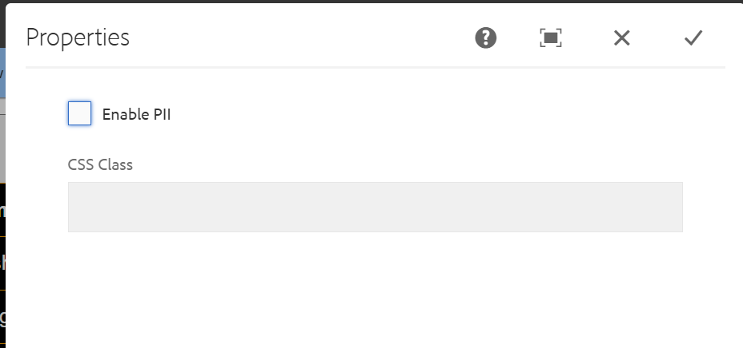

**CHECKBOX ENABLE AND TEXTFIELD ENABLED**

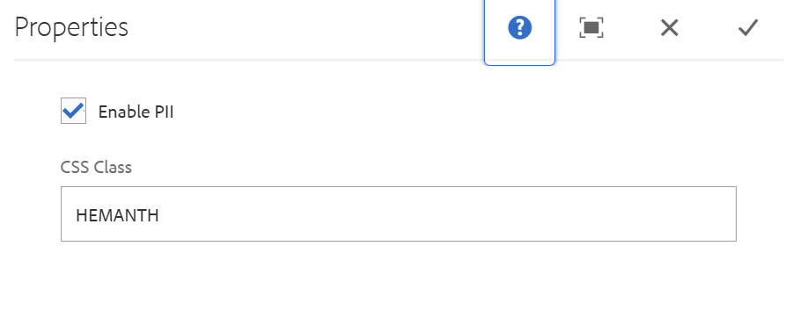**COMPONENT DISPLAY ON PAGE**

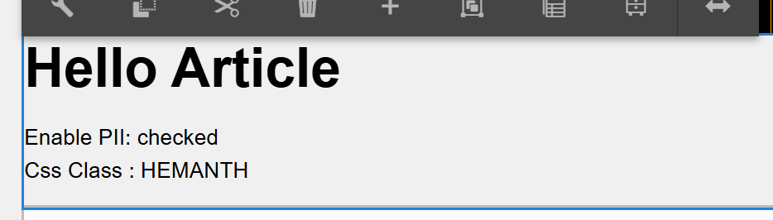

**SERVLET CODE FOR DELETETING TEXTFIELD**

**package com.adobe.aem.guides.demo.core.servlets;**

**import java.io.IOException;**

**import javax.servlet.Servlet;**

**import org.apache.sling.api.SlingHttpServletRequest;**

**import org.apache.sling.api.SlingHttpServletResponse;**

**import org.apache.sling.api.resource.ModifiableValueMap;**

**import org.apache.sling.api.resource.PersistenceException;**

**import org.apache.sling.api.resource.Resource;**

**import org.apache.sling.api.resource.ResourceResolver;**

**import org.apache.sling.api.servlets.SlingAllMethodsServlet;**

**import org.osgi.service.component.annotations.Component;**

**@Component(**

**service = Servlet.class,**

**property = {**

**"sling.servlet.methods=POST",**

**"sling.servlet.paths=/bin/deleteContentNode"**

**})**

**public class Cheching extends SlingAllMethodsServlet {**

**protected void doPost(SlingHttpServletRequest request, SlingHttpServletResponse response) throws IOException {**

**String path = request.getParameter("path");**

**if (path == null || path.isEmpty()) {**

**response.setStatus(SlingHttpServletResponse.SC_BAD_REQUEST);**

**response.getWriter().write("Path parameter is missing");**

**return;**

**}**

**// Replace _jcr_content with jcr:content**

**String modifiedPath = path.replace("_jcr_content", "jcr:content");**

**// Print the received path and modified path**

**response.getWriter().write("Received path: " + path + "\n");**

**response.getWriter().write("Modified path: " + modifiedPath + "\n");**

**ResourceResolver resolver = request.getResourceResolver();**

**try {**

**Resource resource = resolver.getResource(modifiedPath);**

**if (resource != null) {**

**ModifiableValueMap valueMap = resource.adaptTo(ModifiableValueMap.class);**

**if (valueMap != null) {**

**// Remove the "cssClass" property if it exists**

**if (valueMap.containsKey("textfield")) {**

**valueMap.remove("textfield");**

**}**

**resolver.commit();**

**response.setStatus(SlingHttpServletResponse.SC_OK);**

**response.getWriter().write("Content node deleted and 'cssClass' property removed if it existed.");**

**} else {**

**response.setStatus(SlingHttpServletResponse.SC_INTERNAL_SERVER_ERROR);**

**response.getWriter().write("Unable to adapt resource to ModifiableValueMap.");**

**}**

**} else {**

**response.setStatus(SlingHttpServletResponse.SC_NOT_FOUND);**

**response.getWriter().write("Content node not found.");**

**}**

**} catch (PersistenceException e) {**

**response.setStatus(SlingHttpServletResponse.SC_INTERNAL_SERVER_ERROR);**

**response.getWriter().write("PersistenceException: " + e.getMessage());**

**}**

**}}**